Power BI Custom Visual Step by Step

Step 3 D3

<1> Induction to D3: Data-Driven Documents

D3 (or D3.js) is a JavaScript library for visualizing data using web standards. D3 helps you bring data to life using SVG, Canvas and HTML. D3 combines powerful visualization and interaction techniques with a data-driven approach to DOM manipulation, giving you the full capabilities of modern browsers and the freedom to design the right visual interface for your data.

<2> Install D3 with npm

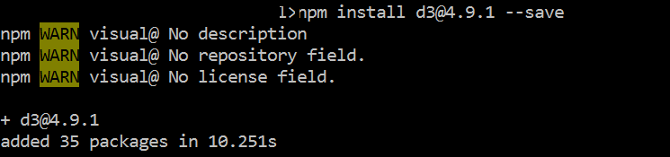

<3> Including d3 to the pbiviz.json

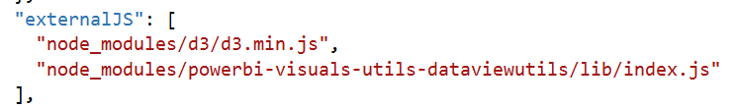

<4> Installing Typings for d3

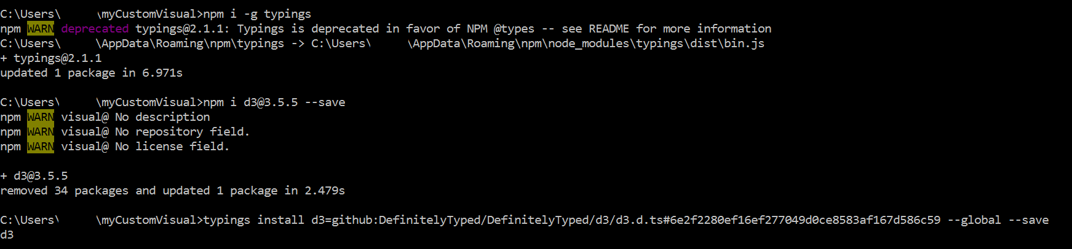

Then we can see Typings Folder has been added to the folder

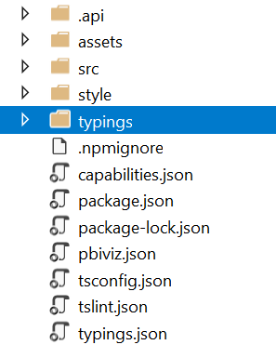

Add Typing to tsconfig.json

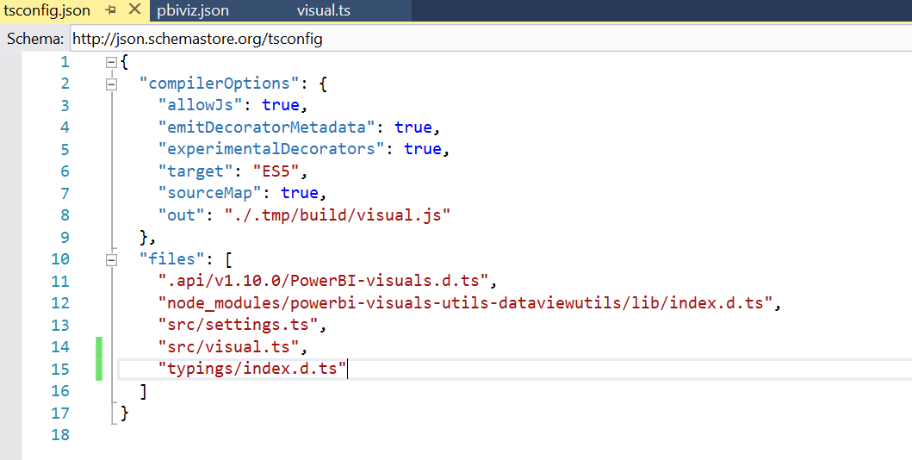

Then we can add svg element to custom visual